**Date Base Project**

**As SYS**

create user manager_user identified by 123;

create role create_users_role;

grant create session, create user to create_users_role;

grant create_users_role to manager_user;

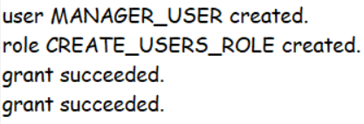

------------------------------------------------------------------------------------------------------------------

**As manager_user**

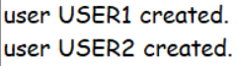create user user1 identified by 123;

create user user2 identified by 123;

------------------------------------------------------------------------------------------------------------------

**As SYS**

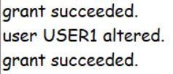grant create session, create table to user1;

alter user user1 quota 50M on system;

grant create session to user2;

------------------------------------------------------------------------------------------------------------------

**AS user1**

create table Department (

ID INTEGER PRIMARY KEY,

department_name VARCHAR2(50)

);

create table Employees (

ID INTEGER PRIMARY KEY,

name VARCHAR2(50),

salary NUMBER,

department_id NUMBER REFERENCES Department(ID)

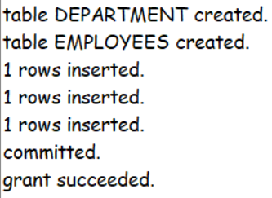);

insert into Department values(1,'HR');

insert into Department values(2,'IT');

insert into Department values(3,'Finance');

commit;

grant all on Employees to user2;

------------------------------------------------------------------------------------------------------------------

**As user2**

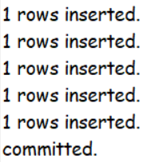INSERT INTO user1.Employees VALUES (1, 'Ahmed', 20000, 1);

INSERT INTO user1.Employees VALUES (2, 'Youssef', 40000, 1);

INSERT INTO user1.Employees VALUES (3, 'Mohamed', 60000, 2);

INSERT INTO user1.Employees VALUES (4, 'Mostafa', 80000, 2);

INSERT INTO user1.Employees VALUES (5, 'Karim', 100000, 3);

commit;

------------------------------------------------------------------------------------------------------------------

**As user1**

update Employees set salary = salary * 1.1 where department_id = 1;

**As user2**

UPDATE user1.Employees SET salary = salary * 1.1 WHERE department_id = 1;



**As SYS**

select username, sid, serial#, blocking_session, seconds_in_wait from v$session where blocking_session is not null;



------------------------------------------------------------------------------------------------------------------

**As user1**

update Employees set salary = salary * 1.1 where department_id = 1;

**As user2**

update user1.Employees set salary = salary * 1.1 where department_id = 2; **As user1**

update Employees set salary = salary * 1.1 where department_id = 2;



**As user2**

update user1.Employees set salary = salary * 1.1 where department_id = 1;



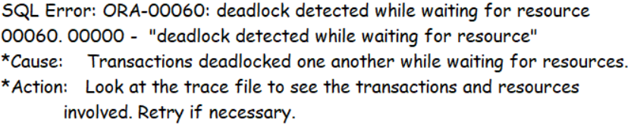

------------------------------------------------------------------------------------------------------------------

**As SYS**

set serveroutput on;

CREATE OR REPLACE FUNCTION avg_salary(req_id INTEGER)

RETURN NUMBER IS avg_salary NUMBER;

BEGIN

SELECT AVG(salary) INTO avg_salary FROM user1.Employees  
 WHERE req_id = department_id;

RETURN avg_salary;

END;

/

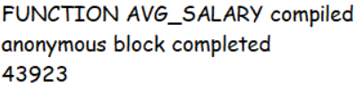begin

dbms_output.put_line(avg_salary(1));

end;

------------------------------------------------------------------------------------------------------------------

CREATE OR REPLACE FUNCTION total_salary(req_id INTEGER)   
RETURN NUMBER IS total_salary NUMBER;

BEGIN

SELECT SUM(salary) INTO total_salary FROM user1.Employees   
 WHERE req_id = department_id;

RETURN total_salary;

END;

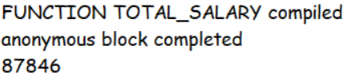/

begin

dbms_output.put_line(total_salary(1));

end;

------------------------------------------------------------------------------------------------------------------

CREATE OR REPLACE FUNCTION max_salary   
RETURN NUMBER IS max_salary_val NUMBER;

BEGIN

SELECT MAX(salary) INTO max_salary_val FROM user1.Employees;

RETURN max_salary_val;

END;

/

begin

dbms_output.put_line(max_salary);

end;

